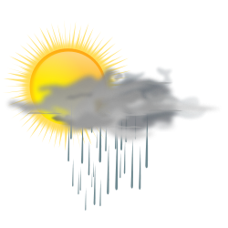

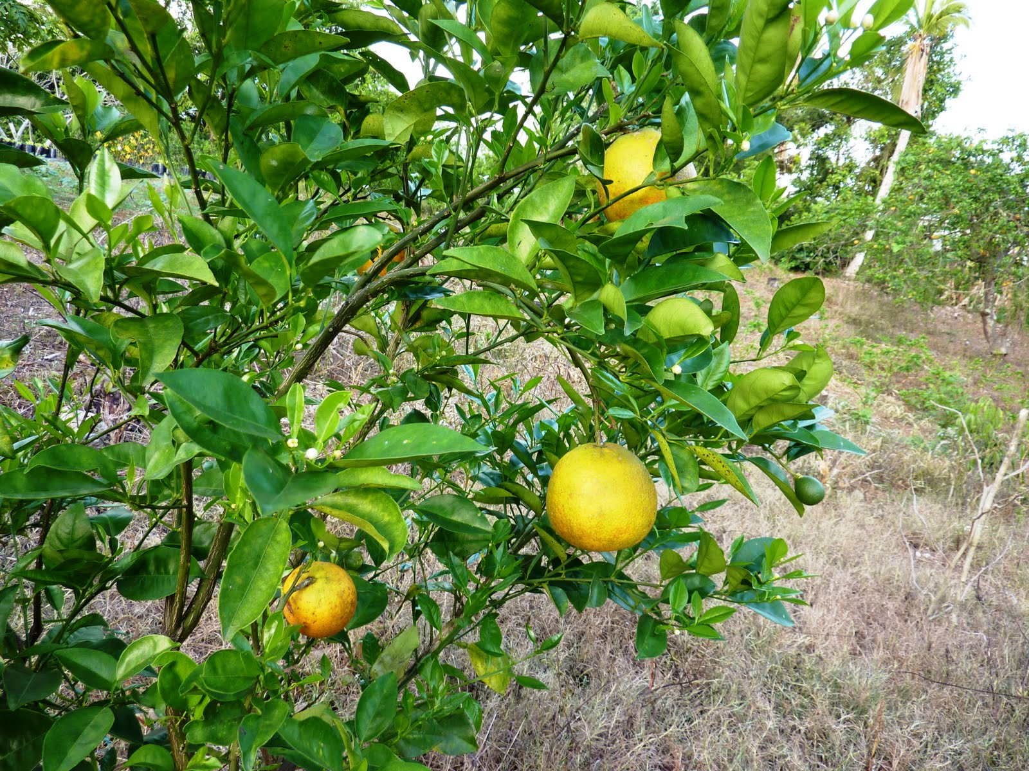

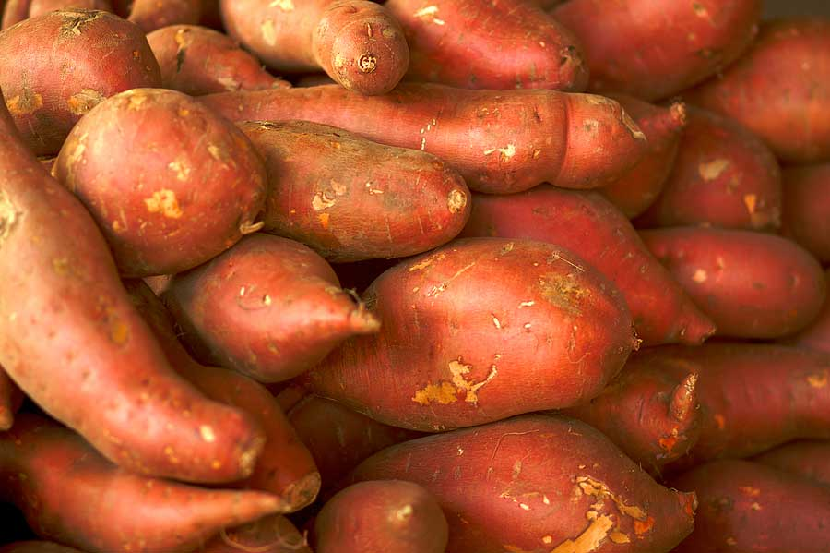
NATIONAL AGROMET BULLETIN

Issued by
Climate Branch
Meteorological Service, Jamaica
65 ¾ Half Way Tree Road
Kingston 10
Telephone: 929-3700/3706
Email: datarequest@metservice.gov.jm
September 2015
Highlights for September 2015

- Exceptional drought conditions reported for eastern and some southern stations.

- Below normal rainfall is forecast for stations over eastern and some western parishes for October through December.

- Above normal temperatures forecast to continue through December 2015.

Weather Summary for month of September 2015

Throughout the month of September surface troughs were the dominant weather feature affecting the island. The expected rainfall activity did not materialize and instead mainly sunny conditions were seen except for a few occasional showers over some central and western parishes.
During the month, Sangster in the northwest recorded 92.2 mm of rainfall, while Norman Manley in the southeast recorded 3.5 mm of rainfall. There were three (8) rainfall days reported for Sangster while Norman Manley International Airport had only one (1) rain day. Manley received well below the average rainfall for the month of September while Sangster received approximately 70 percent of the 30 year rainfall mean.
The highest maximum temperature recorded for Norman Manley Airport was 34.4°C (12th September) meanwhile Sangster Airport reported 34.3C (10th September).

Standardized Precipitation Index (SPI)

The Standardized Precipitation Index (SPI), developed by T.B. McKee, N.J. Doesken, and J. Kleist in 1993, is based only on precipitation. One unique feature is that the SPI can be used to monitor conditions on a variety of time scales namely 1- month, 3-month, 6-monrth, 9-month and 12-month periods. This temporal flexibility allows the SPI to be useful in both short-term agricultural and long-term hydrological applications.
KEY
SPI Value | Category |  | SPI Value | Category
-0.5 to -0.7 | Abnormally Dry  (30%tile) |  | 0.5 to 0.7 | Abnormal Wetness (70%tile)
-0.8 to -1.2 | Moderate Drought  (20%tile) |  | 0.8 to 1.2 | Moderate Wetness  (80%tile)
-1.3 to -1.5 | Severe Drought  (10%tile) |  | 1.3 to 1.5 | Severe Wetness  (90%tile)
-1.6 to -1.9 | Extreme Drought  (5%tile) |  | 1.6 to 1.9 | Extreme Wetness  (95%tile)
-2.0 or less | Exceptional Drought  (2%tile) |  | 2.0 or more | Exceptional Wetness  (98%tile)

Table 1. Rainfall and Drought Analysis for Selected Stations
Parish | Station | September  Monthly Total (mm) | Percent of 30 year Mean (%) | SPI for September
Hanover | Mount Peto | 284 | 77 | -1.06
Westmoreland | Sav-La-Mar | 193 | 87 | -1.40
Westmoreland | Frome | 146 | 61 | -0.69
Manchester | Sutton | 308 | 130 | -0.06
St. Elizabeth | Y.S. Estates | 265 | 103 | 0.35
St. Elizabeth | Potsdam | 53 | 30 | -1.54
Clarendon | Beckford Kraal | 68 | 33 | -1.96
St. Catherine | Tulloch | 135 | 57 | -1.93
St. Catherine | Worthy Park | 58 | 31 | -2.47
Trelawny | Orange Valley | 29 | 28 | -1.47
St. James | Sangster | 92 | 70 | -1.51
St. Ann | Cave Valley | 163 | 128 | 0.35
St. Mary | Hampstead | 72 | 77 | -0.89
Portland | Shirley Castle | 12 | 6 | -1.91
St. Thomas | Serge Island | 79 | 31 | -1.84
KSA | Langley | 147 | 53 | -1.15
KSA | Manley Airport | 4 | 2 | -2.09

Standardized Precipitation Index Discussion
Thirteen of the seventeen reporting stations were showing varying levels of drought, with two stations namely, Worthy Park in St. Catherine and Manley Airport in KSA showing exceptional drought, which represents the lowest level on the SPI scale (see Key above). Jamaica is in the primary rainfall season however, the island continues to have below normal rainfall activity especially over eastern and some central parishes, as shown in figure 1 (see below).

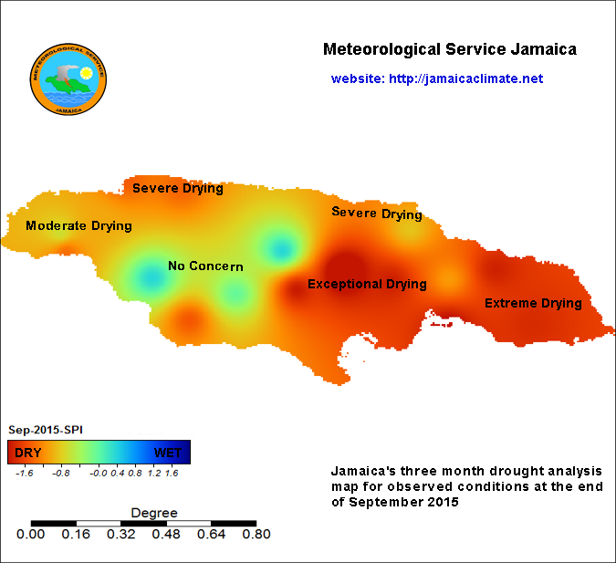

Fig.1 Station drought condition for September 2015

Precipitation Outlook – October to December 2015

The rainfall outlooks for the period October to December, from the Global Dynamic Models as well as Climate Predictability Tool (CPT) are indicating warmer than normal temperatures with below normal rainfall for the Caribbean.
Of the seventeen rainfall stations that were examined across Jamaica, most stations over eastern
and some central parishes are likely to continue receiving below normal rainfall. Our most recent
forecast indicates that the parishes of Clarendon, St Catherine, St. Thomas, Portland, St Mary St Ann, as well as, St. James will experience the greatest deficit in rainfall during the next 3-month period.

Table 2. Climate Predictability Tool (CPT) Outlook OND 2015.
Stations | Below (B) % | Normal (N) % | Above (A) %
Manley Airport (KSA) | 30 | 10 | 60
Sangster Airport (St. James) | 35 | 15 | 50
Sav-La-Mar (Westmoreland) | 40 | 30 | 30
Beckford Kraal (Clarendon) | 30 | 10 | 60
Serge Island (St. Thomas) | 65 | 20 | 15
Cave Valley (St. Ann) | 40 | 25 | 35
Tulloch Estate (St. Catherine) | 30 | 15 | 55
Y.S. Estate (St. Elizabeth) | 25 | 30 | 45
Hampstead (St. Mary) | 60 | 15 | 25
Orange Valley (Trelawny) | 50 | 30 | 20
Langley (KSA) | 45 | 25 | 30
Mount Peto (Hanover) | 45 | 25 | 30
Shirley Castle (Portland) | 50 | 30 | 20
Sutton (Manchester) | 20 | 15 | 65
Potsdam (St. Elizabeth) | 30 | 10 | 60
Frome (Westmoreland) | 20 | 30 | 50
Worthy Park (St. Catherine) | 45 | 25 | 30
JAMAICA | 40 | 25 | 35

Key

A: Above normal rainfall means greater than 66 percentile of the rank data
N: Near normal rainfall means between 33 and 66 percentile of the rank data
B: Below normal rainfall means below 33 percentile of the rank data

Drought Forecast – December 2015

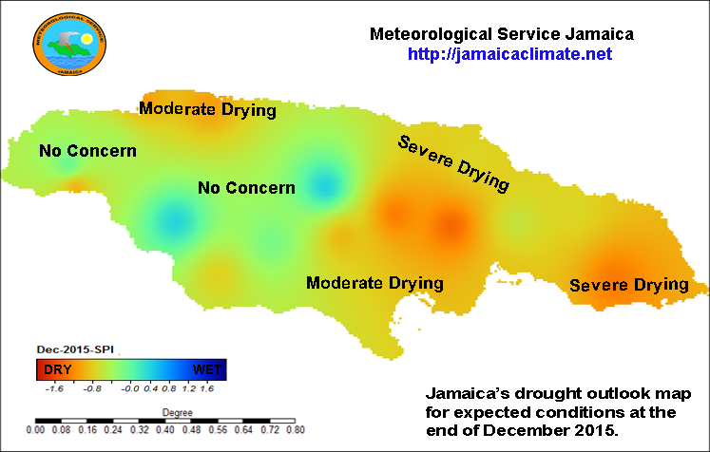

Fig.2 Expected drought conditions by end of December 2015

Temperature Forecast – October to December 2015

Location | Below (B) % | Normal (N) % | Above (A) %
Jamaica Temperature Outlook | 15 | 10 | 75

Summary and Expected Agricultural Impacts

Precipitation forecast through December remains below normal for most stations with highest
deficits expected for eastern and some central parishes. Although rainfall is expected during the month of October it will be insufficient to break the prolonged drought affecting sections of the island.
El Nino continues to be the driving force for the drought being experienced and it is now showing a strong possibility of continuing into the dry season (Dec 2015 - Mar 2016). The impact of this would be very severe especially for farming communities and other water users.
Plans should be nearing completion for the remainder of this year as well as early 2016 which could include the early rainfall season (April/May 2016). This will ensure that whatever situation unfolds it can be properly managed.

